**CSS Class & JS Dark and Light Theme Mode**

This is advance feature of CSS dark and light theme mode that toggle between them

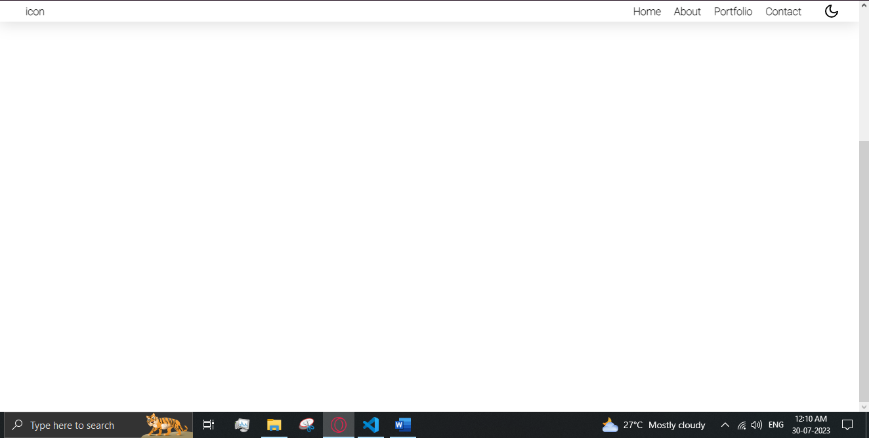

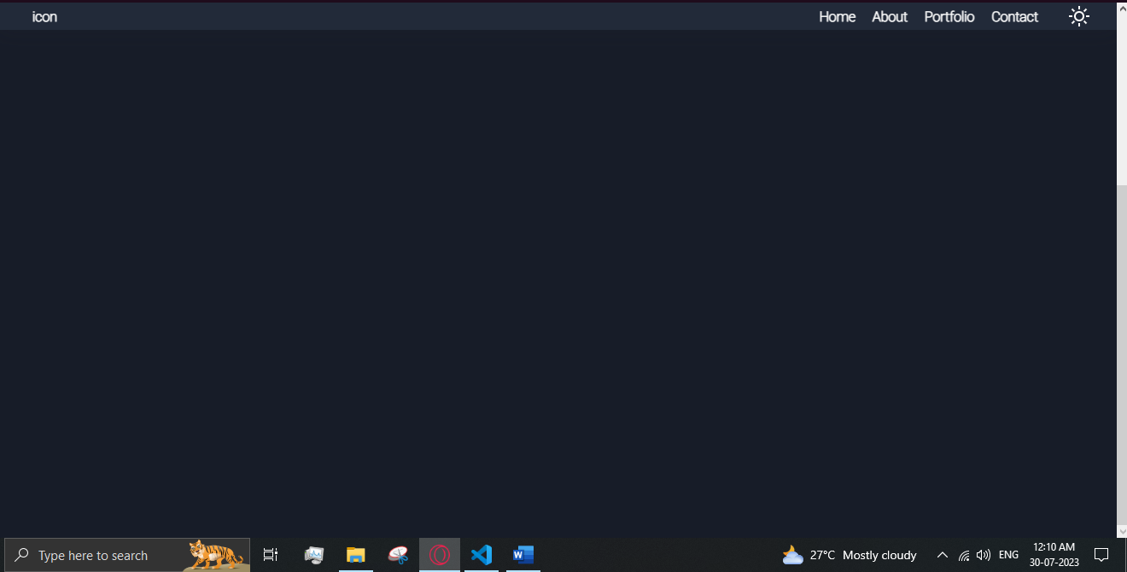

HTML

  <div>

<div onClick={DarkTheme} className="ThemeIcons"> <div id="themeicons" className="gg-moon"></div></div>

  </div>

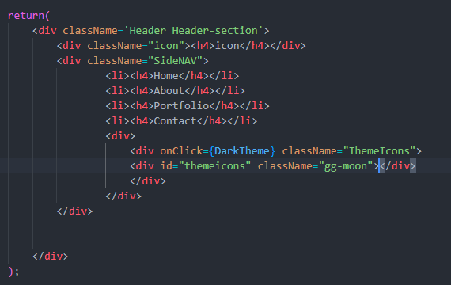

CSS

/* Global Variables */

:root{

    --base-text-clr:black;

    --background-Header:white;

    --background:white;

    /* box showdow color */

    --showdow-box:0 2px 24px 0 rgb(0 0 0 / 15%);

}

/* darkMode Theme */

.darkmode{

    --base-text-clr:white;

    --background-Header:#232a3a;

    --background:#181c28;

    /* box showdow color*/

    --showdow-box:0 2px 24px 0 rgba(40, 40, 53, 0.15);

}

    /* homepage background color translation*/

.homePage{

width: 100%;

height: 150vh;

background-color:var(--background);

transition-property: background-color;

transition-duration: 500ms;

}

.ThemeIcons{

    margin-left: 1.0em;

    cursor: pointer;

}

/* Icon */

/* Light Theme Icon (sun) */

.gg-sun {

    box-sizing: border-box;

    position: relative;

    display: block;

    transform: scale(var(--ggs,1));

    width: 24px;

    height: 24px;

    background:

      linear-gradient(to bottom,

          currentColor 4px,transparent 0)

          no-repeat 5px -6px/2px 6px,

      linear-gradient(to bottom,

          currentColor 4px,transparent 0)

          no-repeat 5px 14px/2px 6px,

      linear-gradient(to bottom,

          currentColor 4px,transparent 0)

          no-repeat -8px 5px/6px 2px,

      linear-gradient(to bottom,

          currentColor 4px,transparent 0)

          no-repeat 14px 5px/6px 2px;

    border-radius: 100px;

    box-shadow: inset 0 0 0 2px;

    border: 6px solid transparent

  }

  .gg-sun::after,

  .gg-sun::before {

    content: "";

    display: block;

    box-sizing: border-box;

    position: absolute;

    width: 24px;

    height: 2px;

    border-right: 4px solid;

    border-left: 4px solid;

    left: -6px;

    top: 5px

  }

  .gg-sun::before {

    transform: rotate(-45deg)

  }

  .gg-sun::after {

    transform: rotate(45deg)

  }

  /* $$ */

.ThemeIcons :hover{

    transition: all 1s ease-in-out 0s;

    transform: rotate(230deg);

}

/* Moon Icon */

.gg-moon,

.gg-moon::after {

    display: block;

    box-sizing: border-box;

    border-radius: 50%

}

.gg-moon {

    overflow: hidden;

    position: relative;

    transform: rotate(-135deg) scale(var(--ggs,1));

    width: 20px;

    height: 20px;

    border: 2px solid;

    border-bottom-color: transparent

}

.gg-moon::after {

    content: "";

    position: absolute;

    width: 12px;

    height: 18px;

    border: 2px solid transparent;

    box-shadow: 0 0 0 2px;

    top: 8px;

    left: 2px

}

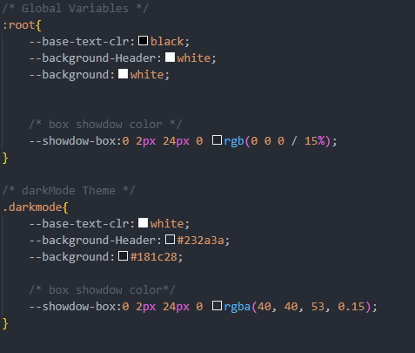

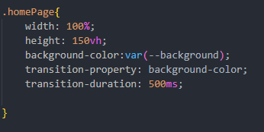

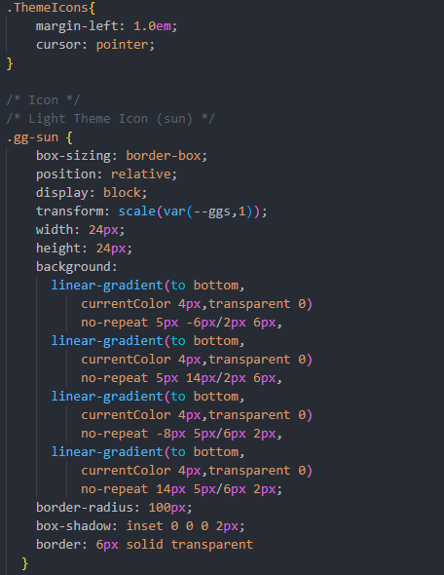

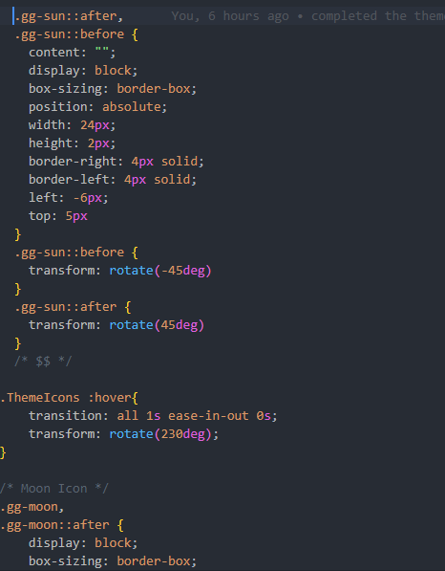

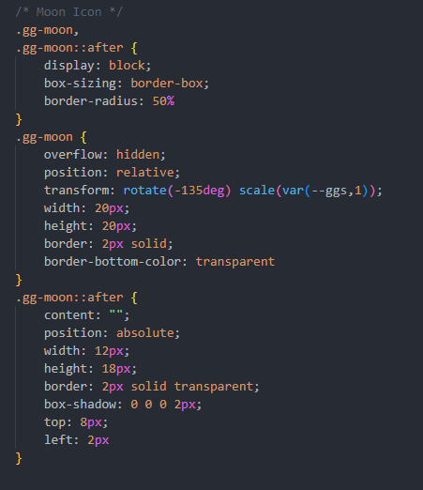

JS

 // local storage for saving the visits

    // click for saved 'darkMode' in localStorage

    let darkMode = localStorage.getItem('darkMode');

    //To enabled DarkTheme function

    const enableDarkTheme = () => {

        // 1 add the class to the body

        document.body.classList.add('darkmode');

        // 2 Update darkMode in the localStorage

        localStorage.setItem('darkMode','enabled');

    }

    const disableDarkTheme = () => {

        // 1 remove the class to body

        document.body.classList.remove('darkmode');

        // 2 update in localstorage

        localStorage.setItem('darkMode', null);

    }

    // If the user already visited and enabled darkmode

    // start things off with it on

    if(darkMode === "enabled"){

        enableDarkTheme();

    }

    //when user click the button

    // Theme Toggle

    const DarkTheme = () => {

        darkMode = localStorage.getItem('darkMode');

        const themeicon = document.querySelector("#themeicons")

        if(darkMode !== "enabled"){

            enableDarkTheme();

            themeicon.classList.remove("gg-moon")

            themeicon.classList.add("gg-sun")

        }

        else{

            disableDarkTheme();

            themeicon.classList.remove("gg-sun")

            themeicon.classList.add("gg-moon")

        }

    }

    // $$

